**National Institute of Technology Karnataka SurathkaL, Mangalore, India**

**Department of Computer Science and Engineering**



**Database Management System Project**

**Ride SHARE SYSTEM**

Ch Muni Kiran – 221CS119

Ganta Rahul – 221CS122

Harsh Gupta – 221CS128

Faisal Raza – 221CS137

**Contents**

|  |  |  |
| --- | --- | --- |
| S.NO | TOPIC | Page no. |
| 1. | introduction | 03 |
| 2. | Literature survey | 03-04 |
| 3. | objectives | 05 |
| 4. | features | 06-07 |
| 5. | Requirements/specifications  Frontend  Backend | 07-08 |
| 6. | System Design  Schema diagram  Er diagram  Normalization process  Tables  Flowchart | 09-14 |
| 7. | Implementation  Code-snippets  Screenshots | 15-25 |
| 8. | Conclusion  Summary of Project  Achievements of project objectives  Lessons learned | 26-27 |
| 9. | References | 27 |

1. **Introduction**

The Car booking system is being developed for customers so that they can book their vehicles from any part of the world. This application takes information from the customers through filling their details. A customer being registered in the website has the facility to book a vehicle which he requires. It is an online system through which customers can view available cars, register and book car. We developed this project to book a car on rent at the fare charges. In present system all booking work done manually and it takes very hard work to maintain the information of booking and cars. If you want to find which vehicle is available for booking then it takes a lot of time.

It only makes the process more difficult and harder. This aim of the project is to automate the work performed in the car booking management system like records of cab, cabs available for booking, rental charges for cars, store records of the customer. Cabriolet is a car booking software that provides a complete solution to all your day-to-day car booking office running needs. This system helps you to keep the information of customer online. You can check your customer information any time by using this system. Online car booking management system is a unique and innovative product. Based on this information you can take decision regarding your business development.

2. **Literature survey**

The growing popularity of ride-sharing applications has sparked interest in developing solutions tailored to specific communities. This literature review explores existing research on cab-booking applications, focusing on features relevant to our mini-project: ride-sharing matching, booking management, user interaction, and the potential for a college-specific application.

**2.1 Security**

The system should provide a high level of security and integrity of the data held by the system; only authorized personnel of the company can gain access to the company’s secured page on the system. System provides security for the admin by allowing them to enter into the account with their respective ID and password. A user can only enter to their account by using their email and password. Only admin have privileges to update database contents which are used by the user.

**2.2 Performance:**

The system should have high performance rate when executing user’s input and should be able to provide feedback or response within a short time span usually 50 seconds for highly complicated task and 20 to 25 seconds for less complicated task. The system provides user friendly interface, any common people with little knowledge can use the system. System is robust, reliable and fast, provides more efficiency.

**2.3 Reliability:**

It is the probability and percentage of the system performing without any failure for a specific number of uses or amount of time. Car rental system provides reliable interface as it provides data security and data safety. User can rely on the details present in the system, since it is provided by the admin.

**2.4 Consistency:**

The car rental system provides consistency services, by retaining the data present in the database. The user gets the details that are only provided by the admin, thus achieving correctness of data in the database.

**2.5 24/7 Availability:**

Car booking management systems offer users the convenience of booking vehicles at any time of the day or night, without being constrained by the operating hours of traditional rental offices. This accessibility ensures that users can make their travel arrangements whenever it suits them best, whether they're planning ahead or making last-minute bookings.

**2.6** **Location Independence:**

One of the primary advantages of online car rental platforms is their ability to cater to users regardless of their geographic location. Users can access the rental system from anywhere with an internet connection, whether they're at home, in the office, or on the move. This eliminates the need for users to physically visit rental offices, saving them time and effort.

3. **OBJECTIVES**

**3.1 Seamless User Management:**

Create a user table with fields like User ID, Username, Password, Email, Contact Number, and Role (e.g., Admin, Driver, Passenger).

Implement user authentication and authorization mechanisms to ensure secure access to the system based on user roles.

Enable users to register, login, update their profiles, and manage their bookings or vehicle listings as per their role.

**3.2 Streamlined Booking System:**

Design a booking table to store booking details including Booking ID, User ID, Vehicle ID, Pickup Location, Drop-off Location, Date, Time, and Status.

Develop features for users to search for available vehicles based on criteria such as location, date, time, and vehicle type.

Implement a booking process allowing users to reserve vehicles, view booking history, and cancel bookings if necessary.

**3.3 Comprehensive Passenger Reviews:**

Establish a passenger reviews table to capture feedback on the overall experience, vehicle condition, driver behaviour, and other relevant aspects.

Provide functionality for users to submit reviews and ratings after completing a ride, and display aggregated ratings for vehicles and drivers.

Enable administrators to moderate reviews, address complaints, and take necessary actions based on feedback to enhance service quality.

4. **Features**

**4.1 User Registration and Authentication:**

The user needs to provide their first name, last name, email, license number, phone number, password, confirm password, gender for registration. Implement authentication mechanisms to ensure secure access to the platform.

* 1. **Ride Posting and Booking:**

User can view the list of cars. The booking details of cars are provided by the admin. Allow passengers to search for available rides based on their preferences and book seats for desired rides. User can select their preferred car and book for the same. Manage booking information including booking date and payment status.

**4.3 Ride Reviews:**

Allow both drivers and passengers to review each other after completing a ride. Include features for rating the ride experience and leaving comments for feedback.

**4.4 Notifications:**

Provide users with notifications for important events such as new ride postings, booking requests, messages, and updates on their ride statuses. Allow users to manage notification preferences and mark notifications as read or unread.

**4.5 Feedback System:**

Enable users to provide feedback on the platform, drivers, and overall ride experience. Collect feedback on various aspects such as user satisfaction, reliability of drivers, and ease of use of the platform.

**4.6 Admin Panel:**

Create an administrative interface for managing users, rides, reviews, messages, notifications, and other system components. Implement features for monitoring platform activity, resolving disputes, and enforcing community guidelines.

**4.7 Search and Filtering:**

Implement search and filtering functionalities to help users find rides based on criteria such as departure location, destination, departure time, and price. Allow users to save search preferences and receive alerts for matching ride listings.

**4.8 Payment Module:**

User should able to make payment by filling card number, expiry date and CVV are provided by the admin. After payment user will get the payment successful popup window.

5. **Requirement Specifications**

**5.1 Frontend:**

HTML5 is a markup language used for structuring and presenting content on the World Wide Web. It is the fifth and last major HTML version that is a World Wide Web Consortium (W3C) recommendation. The current specification is known as the HTML Living Standard. It is maintained by the Web Hypertext Application Technology Working Group (WHATWG), a consortium of the major browser vendors (Apple, Google, Mozilla, and Microsoft).

Cascading Style Sheets (CSS) is a style sheet language used for describing the presentation of a document written in a markup language such as HTML. CSS is a cornerstone technology of the World Wide Web, alongside HTML and JavaScript. CSS is designed to enable the separation of presentation and content, including layout, colors, and fonts. This separation can improve content accessibility; provide more flexibility and control in the specification of presentation characteristics; enable multiple web pages to share formatting by specifying the relevant CSS in a separate .CSS file, which reduces complexity and repetition in the structural content; and enable the .CSS file to be cached to improve the page load speed between the pages that share the file and its formatting.

JavaScript (JS) is a dynamic computer programming language. It is most commonly used as part of web browsers, whose implementations allow client-side scripts to interact with the user, control the browser, communicate asynchronously, and alter the document content that is displayed. It is also being used in server-side programming, game development and the creation of desktop and mobile applications. JavaScript is a prototype-based scripting language with dynamic typing and has first-class functions. Its syntax was influenced by C. The key design principles within JavaScript are taken from the Self and Scheme programming languages. It is a multiparadigm language, supporting object-oriented, imperative, and functional programming styles.

**5.2 Backend:**

PHP is a server-side scripting language designed for web development but also used as a general-purpose programming language. PHP is now installed on more than 244 million websites and 2.1 million web servers. Originally created by Rasmus Lerdorf in 1995, the reference implementation of PHP is now produced by The PHP Group. While PHP originally stood for Personal Home Page, it now stands for PHP: Hyper Text Preprocess .PHP code is interpreted by a webserver with a PHP processor module, which generates the resulting web page PHP commands can be embedded directly into an HTML source document rather than calling an external file to process data. It has also evolved to include a command-line interface capability and can be used in standalone graphical applications. PHP is free software released under the PHP License. PHP can be deployed on most web servers and also as a standalone shell on almost every operating system and platform, free of charge.

MySQL is a widely used relational database management system (RDBMS) that utilizes Structured Query Language (SQL) for managing databases and performing various operations on the data stored within them. MySQL allows users to efficiently manage relational databases by creating, altering, and dropping database structures, tables, and indexes. These operations enable database administrators to organize and optimize data storage according to their specific requirements. With MySQL, users can manipulate data within database tables by adding, updating, and deleting rows of data. These operations enable users to modify the content of the database dynamically, ensuring data accuracy and relevance. MySQL facilitates the retrieval of subsets of information from databases through the execution of SQL queries. Users can specify criteria to filter and sort data, enabling them to extract relevant information for transaction processing, reporting, and analytical purposes. MySQL is particularly popular in web application development and is often integrated into the LAMP (Linux, Apache, MySQL, PHP/Python/Perl) stack, as well as other 'AMP' stacks. Its scalability, performance, and ease of use make it a preferred choice for powering dynamic and data-driven web applications.

In this project Apache server is used to parse and execute PHP pages, before deploying websites on the server, the website should be tested at the developer side to get a feel of how the website will work on actual server. Therefore, Apache server is like a local server on the developer side, Apache server should be informed about the environment on which it should work. In our project Apache server is configured to work with PHP, in this way all the PHP pages are parsed and executed by the server. When Apache is installed on the system, then it services is controlled by Apache service monitor.

6. **System Design**

**6.1 Database Schema Diagram:**

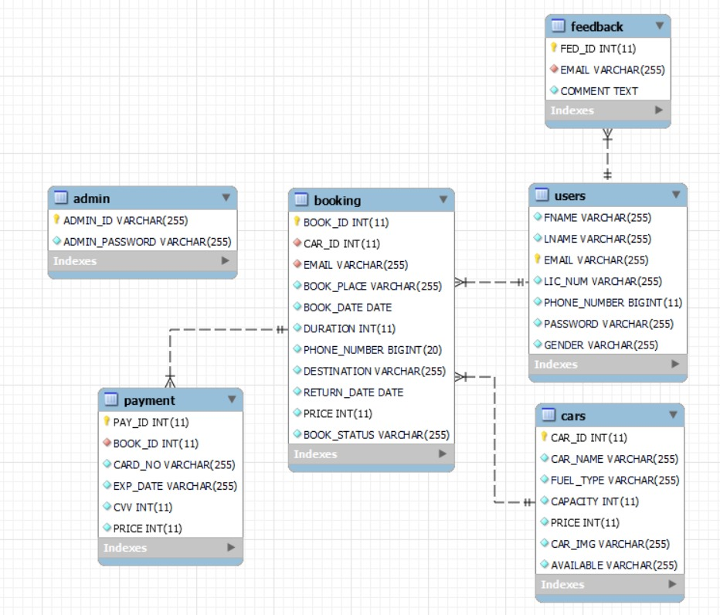

**6.2 ER Diagram:**

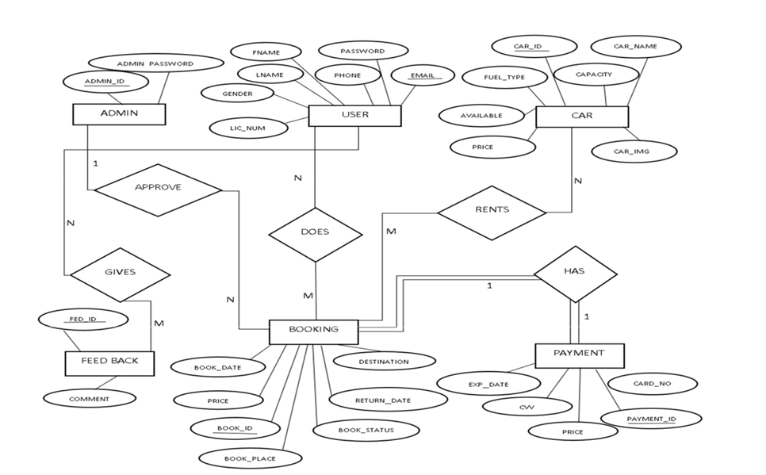

**6.3 Normalisation Process:**

Normalization is a database design technique used to organize data in a relational database efficiently. It aims to reduce data redundancy and dependency by organizing data into separate tables and establishing relationships between them. Normalization helps to minimize data anomalies, such as insertion, update, and deletion anomalies, and ensures data integrity. The normalization process consists of several normal forms, each addressing specific types of data redundancy and dependency.

First Normal Form (1NF)

The first step is to ensure that each table has a primary key, and each attribute (or column) in the table contains atomic values, meaning each cell has a single value, not a list or a set of values. There should be no repeating groups or arrays within a table.

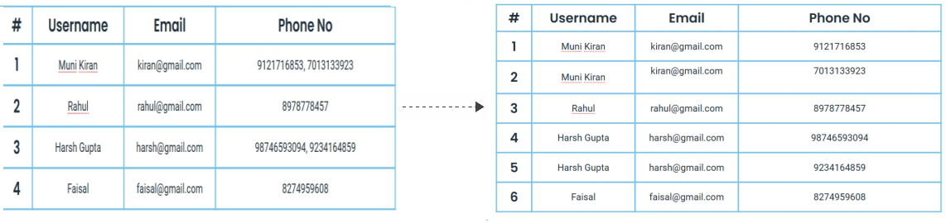

Second Normal Form (2NF)

In addition to meeting the requirements of 1NF, a table is in 2NF if it does not contain any partial dependencies. Partial dependency occurs when a non-prime attribute (an attribute not part of any candidate key) depends on only part of the primary key. To eliminate partial dependencies, we split the table into multiple tables, with related attributes grouped together. Typically, this involves identifying and removing attributes that are functionally dependent on only part of the primary key and placing them in separate tables.

Here's an example how it is done,

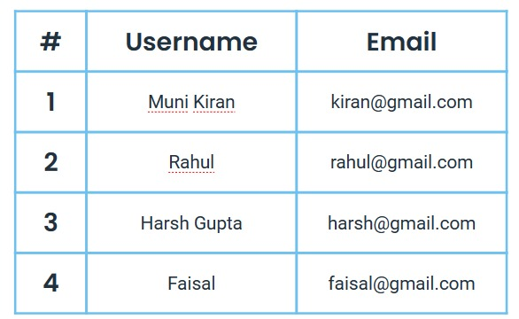 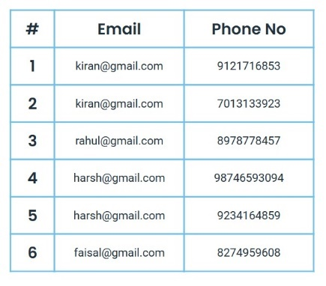

**6.4 Tables:**

**The database consists of six tables:**

ADMIN: It stores the details of admin.

ADMIN-ID: User name of the admin.

ADMIN_PASSWORD: Password of the Admin.

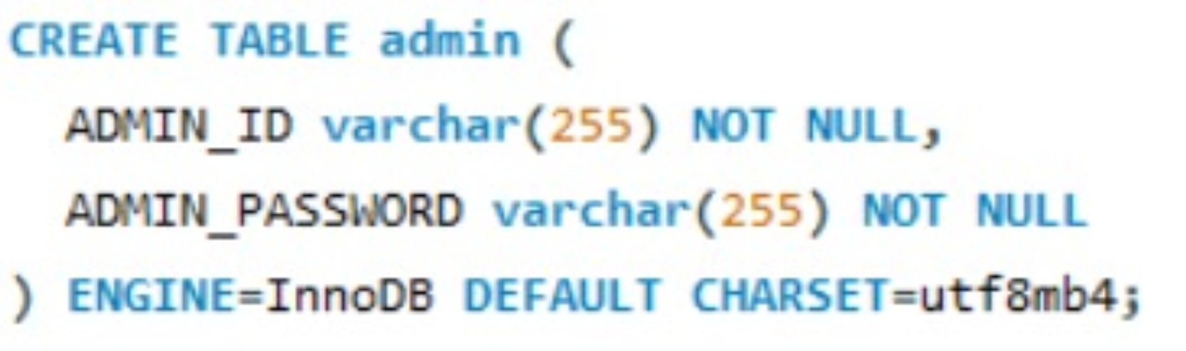

CAR: It gives the details about the car.

CAR_ID: Id given to car done by auto increment.

CAR_NAME: Name of the car.

CAPACITY: Seat capacity.

AVAILABLE: Availability of car.

PRICE: Price of the car.

FUEL_TYPE: Car fuel type.

CAR_IMG: Image of car.

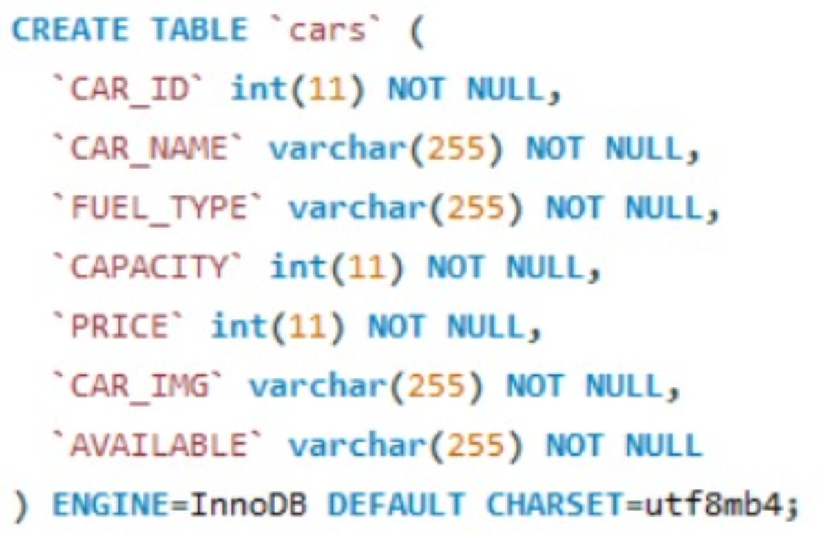

USER: It stores the details of user. FNAME: first name of user.

LNAME: Last name of user.

EMAIL: Email of user.

PASSWORD: Password of user.

GENDER: Gender of user.

PHONE: Phone number of user.

LIC_NUMBER: License no of user.

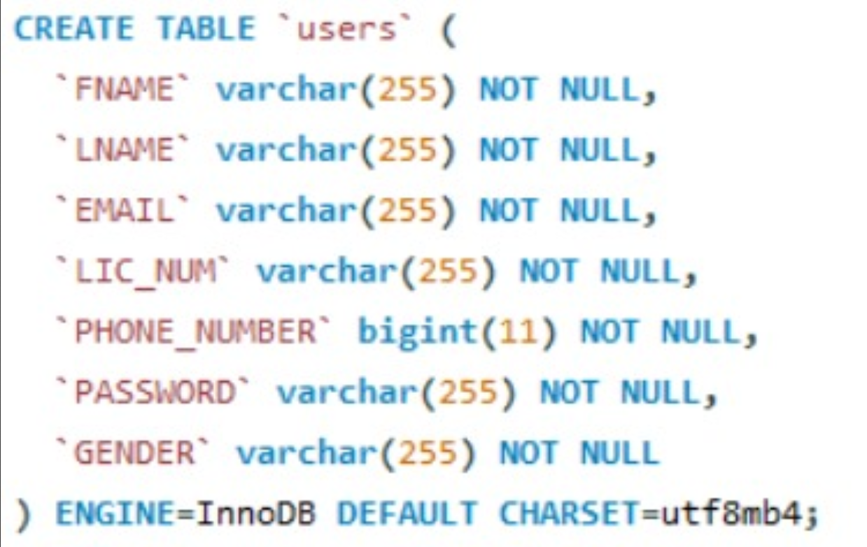

BOOKING: It give the booking details for user. BOOK_ID: Booking id done by auto increment. BOOK_PLACE: Place of booking.

BOOK_DATE: Date of booking.

PRICE: Price of car.

DESTINATION: Destination.

RETURN_DATE: Return date.

CAR_ID: Id given to car and foreign key car associated with booking.

EMAIL: Email of user and foreign key of user associated with booking

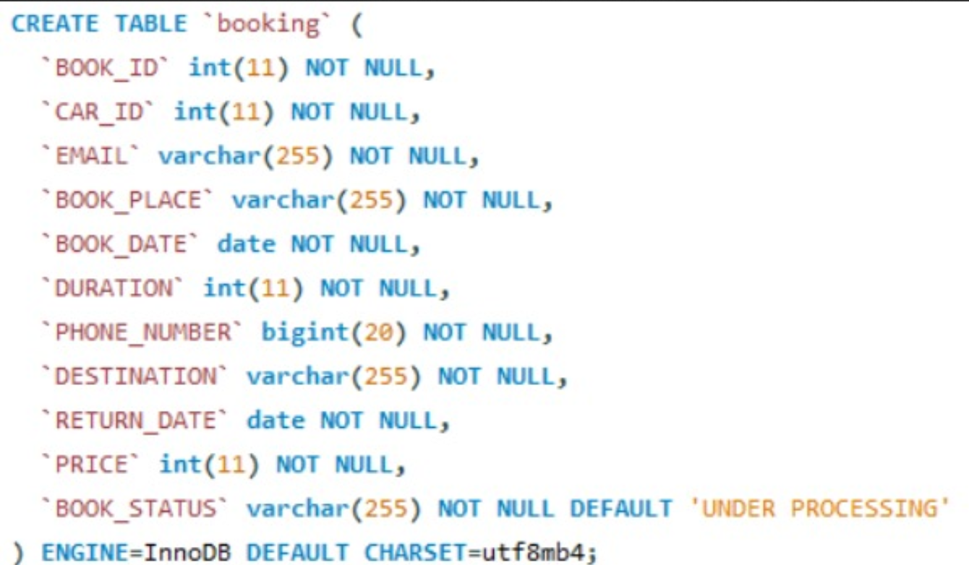

PAYMENT: It provides payment option for users.

PAYMENT_ID: Id given to payment and done by auto increment.

CARD_NO: Card number.

EXP_DATE: Expiry Date of card.

CVV: CVV of card.

PRICE: Price of car.

BOOK_ID: Id given to booking and foreign key of booking associated with payment.

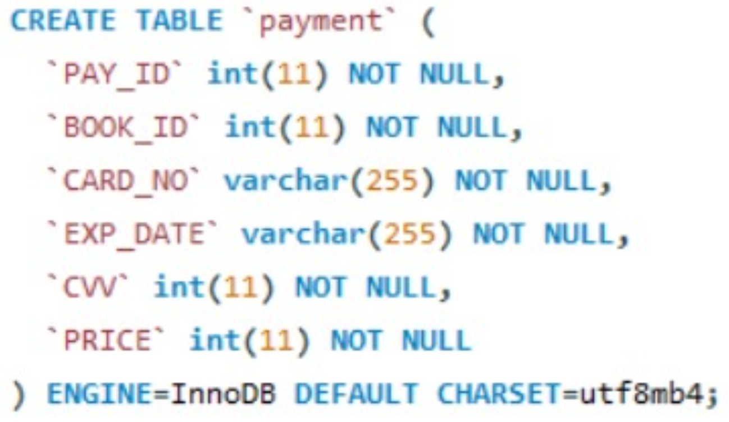

FEEDBACK: It provides user to give their feedback.

FEED_ID: id given to the feedback done by auto increment.

COMMENT: Message about their experience.

EMAIL: Email of user and foreign key of user associated with feedback.

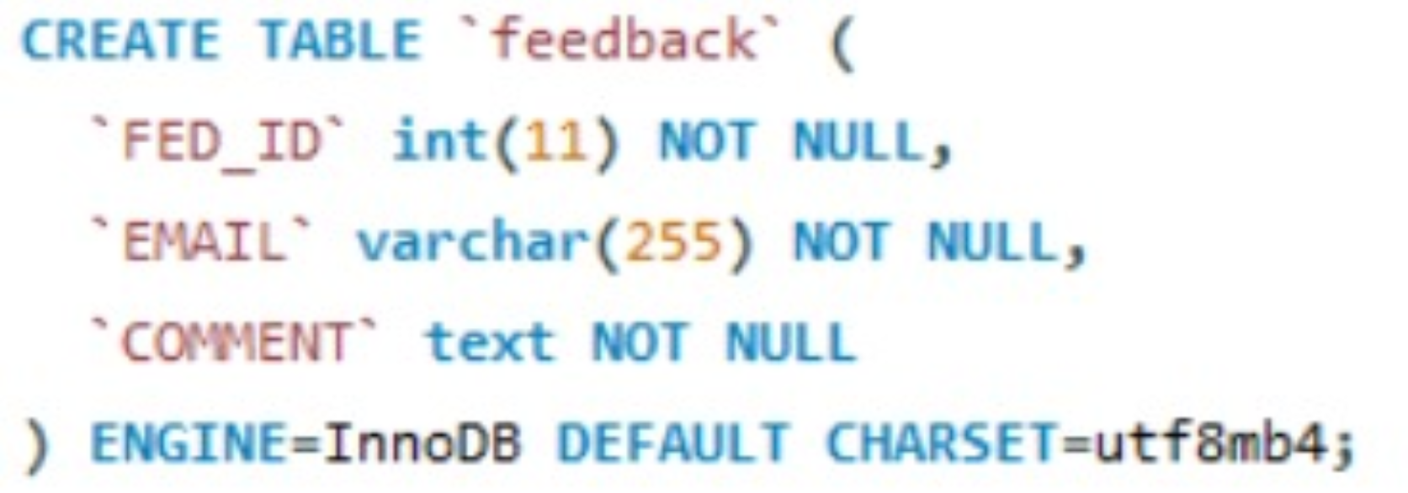

**6.5 Flowchart:**

A flowchart is a diagram that depicts a process, system or computer algorithm. They are widely used in multiple fields to document, study, plan, improve and communicate often complex processes in clear, easy-to-understand diagrams. Flowcharts, sometimes spelled as flow charts, use rectangles, ovals, diamonds and potentially numerous other shapes to define the type of step, along with connecting arrows to define flow and sequence. They can range from simple, hand drawn charts to comprehensive computer-drawn diagrams depicting multiple steps and routes.

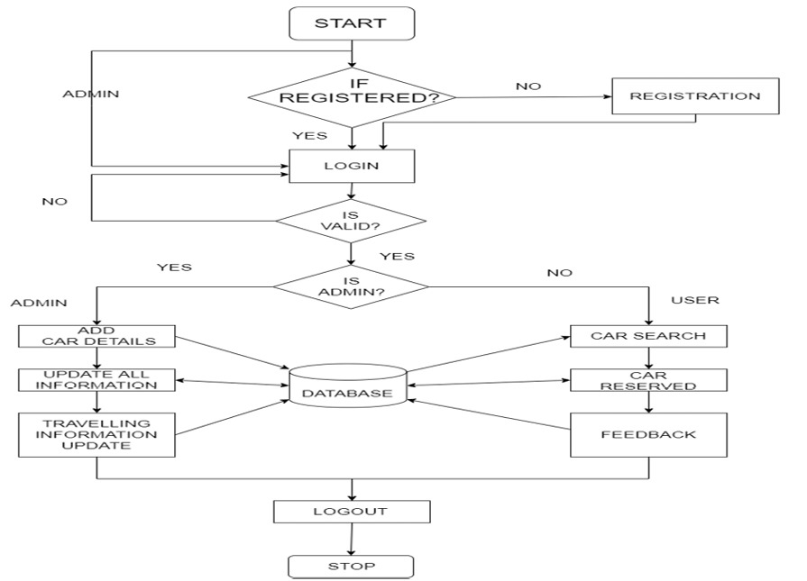

In the above figure the user/admin enters his credentials for registration and later logins. If the login credentials are correct and authentic, he is redirected to his web page. If an admin is an authorized user, he is given the privilege of adding, updating the car, booking, payment details. If an authentic user logs in, he gets the details of car and other related details, then he can view list of cars then he can book car by providing valid details then he can get the booking status of booked status of after making payment. After performing all the operations, the user and admin can save and log out.

7. **Implementation**

PHP: Hypertext Pre-processor (or simply PHP) is a server-side scripting language designed for web development, and also used as a general-purpose programming language. PHP code may be embedded into HTML code, or it can be used in combination with various web template systems, web content management systems, and web frameworks. PHP code is usually processed by a PHP interpreter implemented as a module in the web server or as a Common Gateway Interface (CGI) executable. The web server combines the results of the interpreted and executed PHP code, which may be any type of data, including images, with the generated web page. PHP code may also be executed with a command-line interface (CLI) and can be used to implement standalone graphical applications.

This project uses HTML as front-end tool. Hypertext Mark-up Language (HTML) is the standard mark-up language for creating web pages and web applications. With Cascading Style Sheets (CSS) and JavaScript, it forms a triad of cornerstone technologies for the world wide web. Web browser receive HTML documents from a web server or from local storage and render the documents into multimedia web pages.HTML describes the structure of a web page semantically and originally included cues for the appearance of the document.HTML elements are the building blocks of HTML pages. With HTML constructs, images and other objects such as interactive forms may be embedded into the rendered page.HTML provides a means to create structured documents by structural semantics for text such as headings, paragraphs, lists, links, quotes and other items.HTML elements are delineated by tags, written using angle brackets. Browsers do not display the HTML tags, but use them to interrupt the content of the page.

**7.1 Code Snippet:**

Snippet is a programming term for a small region of re-usable code, machine code or text. Ordinarily, these are formally defined operative units to incorporate into large programming modules. These are few codes written in PHP that includes a database access to fetch, update or delete the data stored and display these data in the website where required. We have also ensured to make sure the backend implementation is free from SQL injection attacks by escaping the query values.

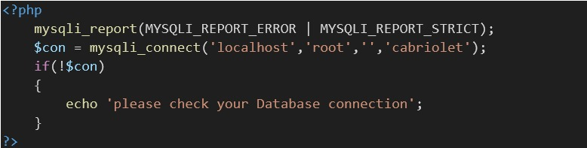

Code Snippet of Connection module

Code snippet is used for connect to the SQL server. This required because other code snippet to connect to the database and then access the data. If the connection fails, it throws an error.

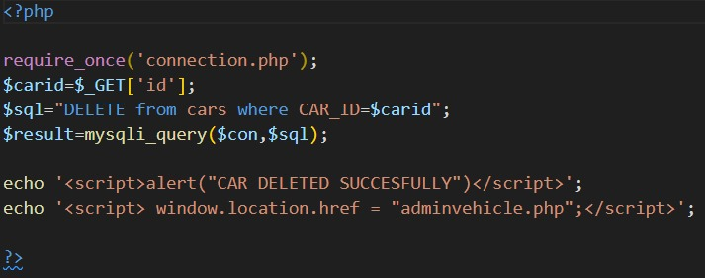

Code Snippet of Delete Car Module

Code snippet indicates the code for the deletion of the car. Only the admin can delete the car.

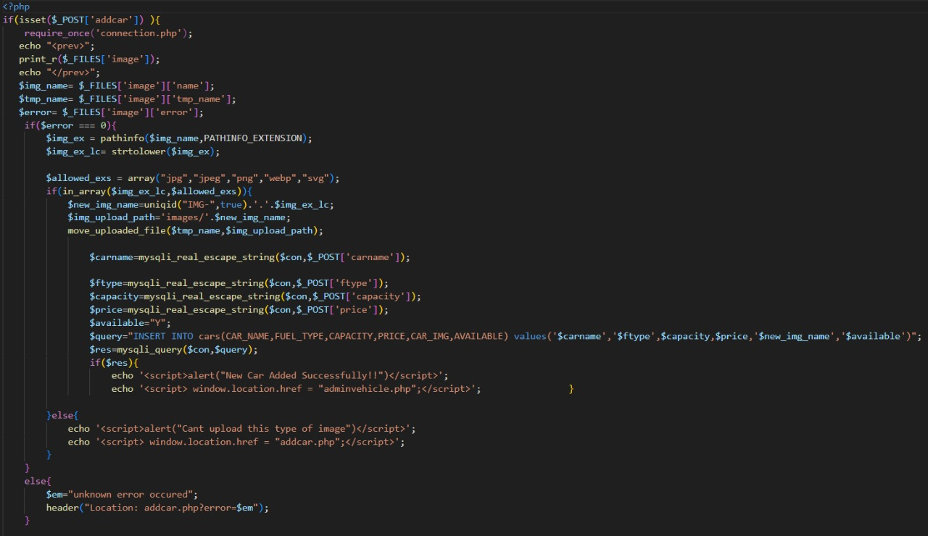

Code Snippet of Uploading Car Image Module

Code snippet indicates the code for the adding the car image from the admin and shows it to user.

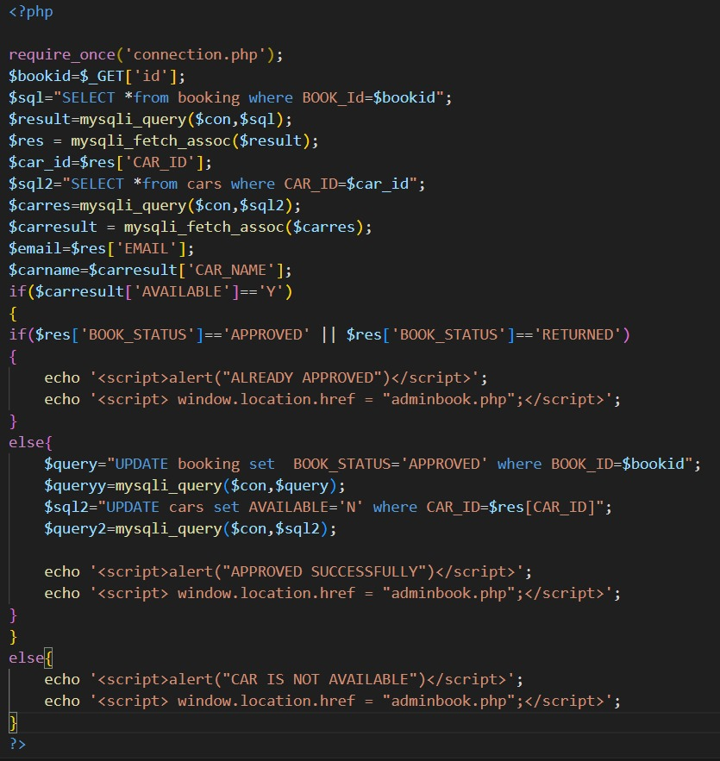

Code Snippet of Approve Module

Code snippet indicates the code for approving the car registered by the user and sends confirmation email to user.

**7.2 Screenshots:**

**7.2.1**

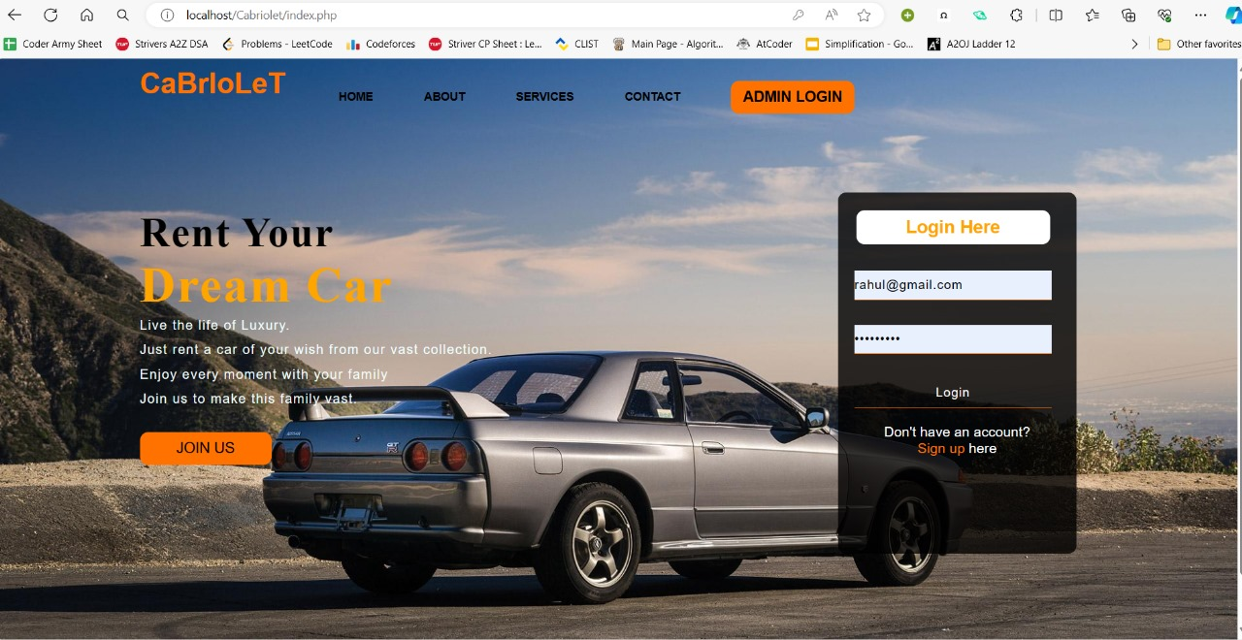

**Fig 7.2.1 Screenshot of Home page**

Figure 7.2.1 indicates the home page of our website CaBrloLet. This contains navigation bar, through which can navigate to other pages. It also contains some details about the website at the home page.

**7.2.2**

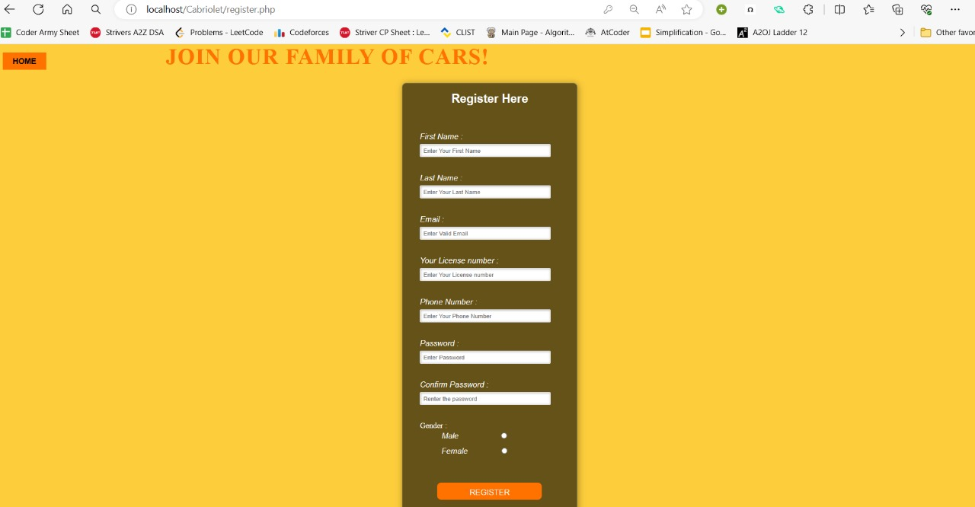

**Fig 7.2.2 Screenshot of User Registration page**

Figure 7.2.2 indicates the user registration page. It asks the user to enter the details like first name, last name, email, license number, phone number, password, confirm password and gender.

**7.2.3**

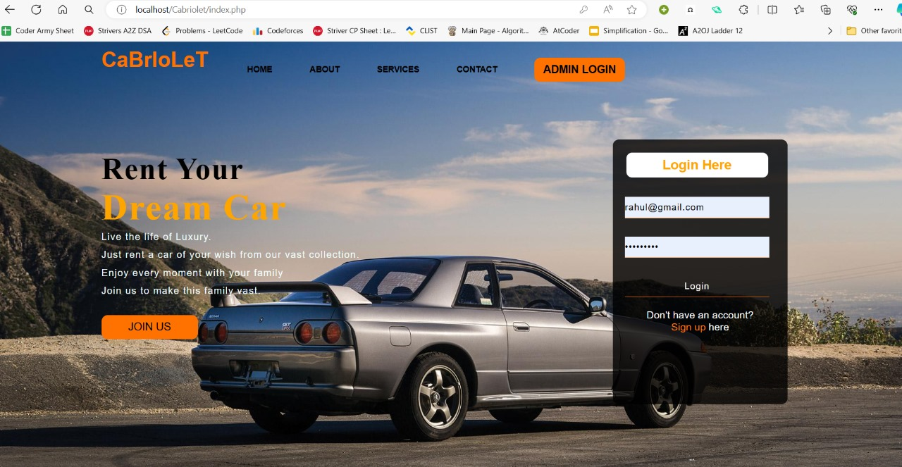

**Fig 7.2.3 Screenshot of User Login page**

Figure 7.2.3 indicates user login page. It asks the user to enter the email and password in order to enter the website CaBrloLeT.

**7.2.4**

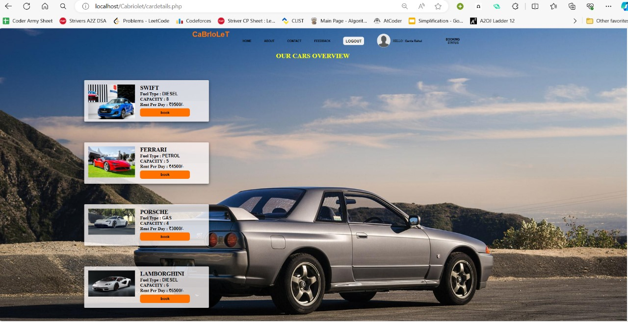

**Fig 7.2.4 Screenshot of View Car page**

Figure 7.2.4 indicates view car page. It asks the user to choose the car it contains the details like fuel type, capacity, rent per day.

**7.2.5**

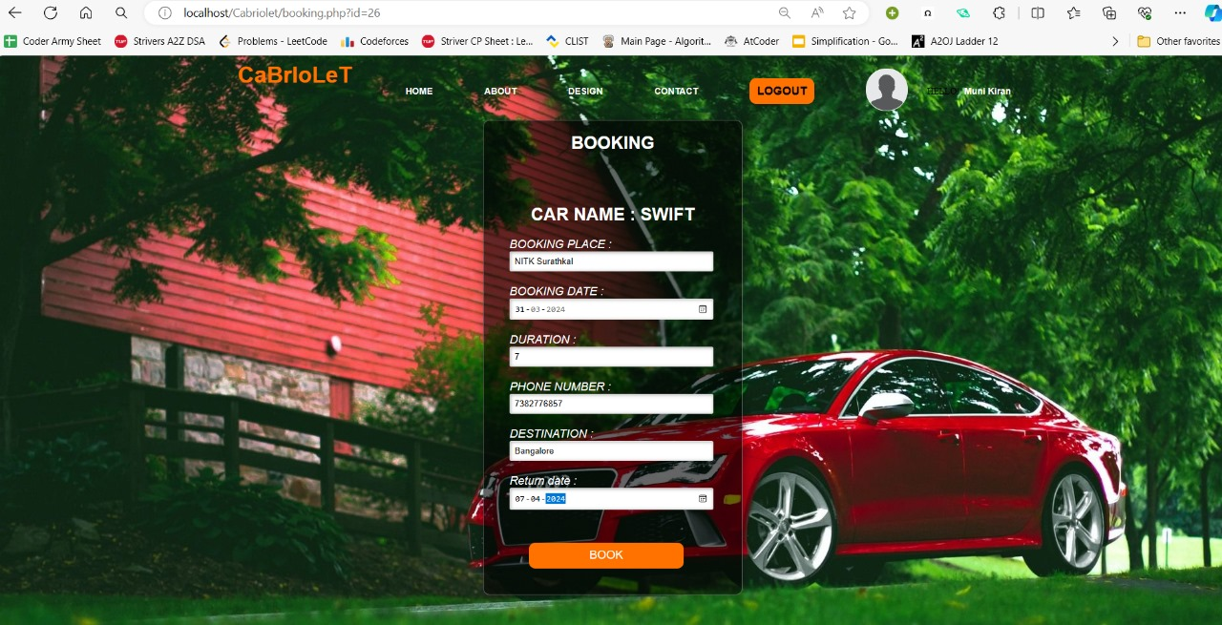

**Figure 7.2.5 Screenshot of Booking page**

Figure 7.2.5 indicates the booking page. It asks the user to enter booking place, booking date, duration, phone number, destination, return date.

**7.2.6**

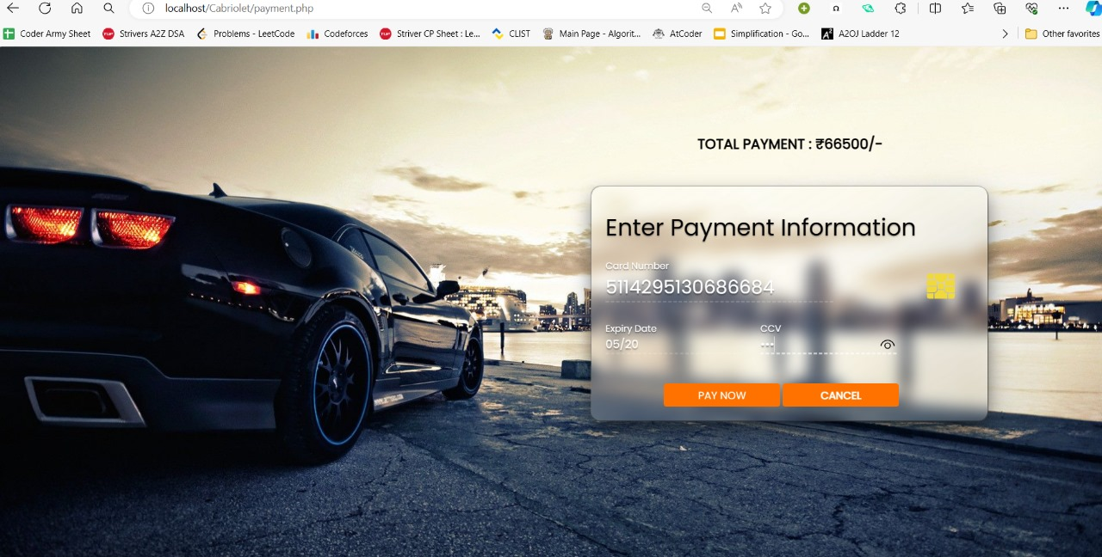

**Fig 7.2.6 Screenshot of Payment page**

Figure 7.2.6 indicates Payment page. It asks the user to enter details like card number, expiry date, ccv.

**7.2.7**

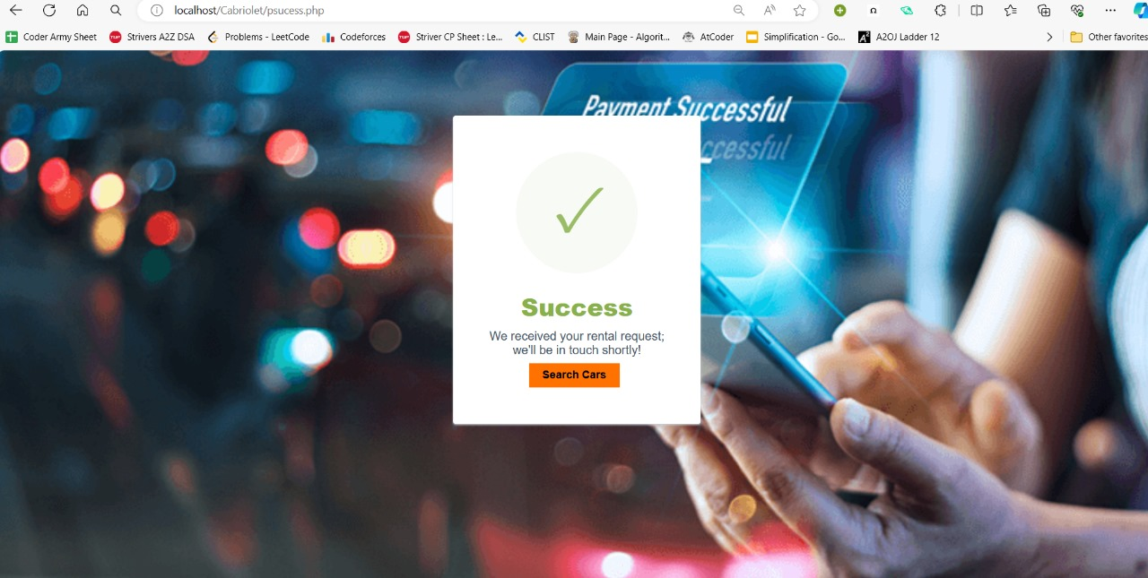

**Fig 7.2.7 Screenshot of Payment Successful page**

Figure 7.2.7 indicates payment successful page. After paying the payment by providing valid information if the payment is successful it shows pop up message that payment is successful.

**7.2.8**

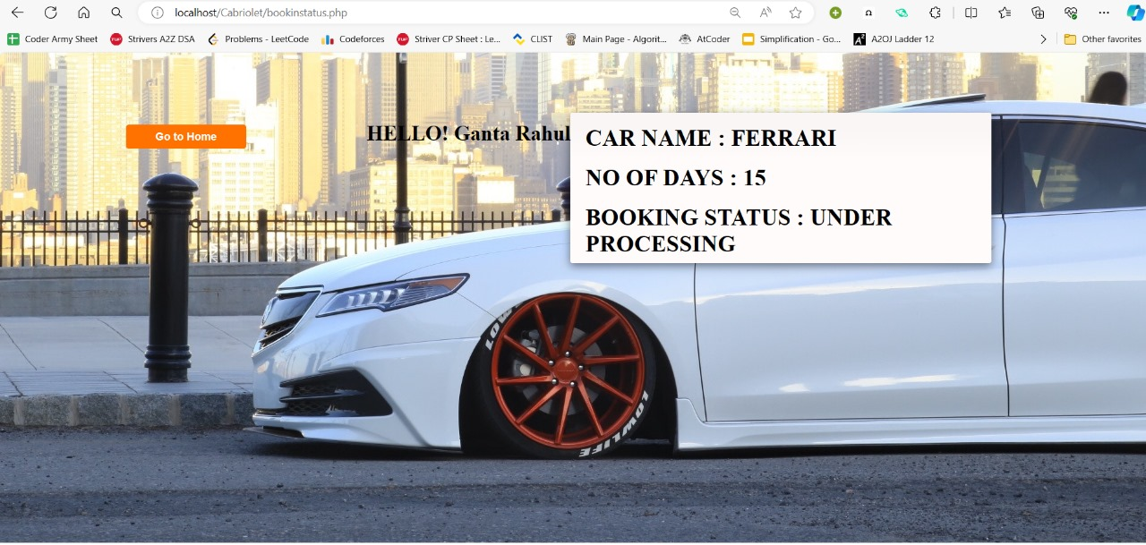

**Fig 7.2.8 Screenshot of Booking Status page**

Figure 7.2.8 indicates booking status page. It shows user booking details.

**7.2.9**

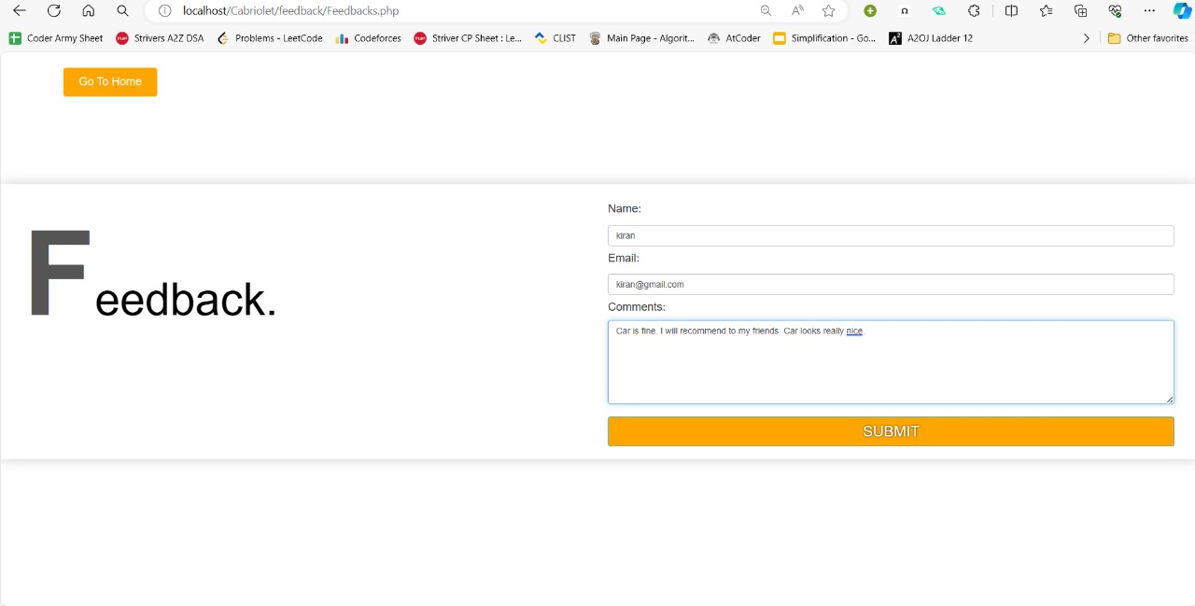

**Fig 7.2.9 Screenshot of Feedback Page**

Figure 7.2.9 indicates Feedback page. It asks the user enter details like name, email, comments where registered user can give their valuable feed of their experience.

**7.2.10**

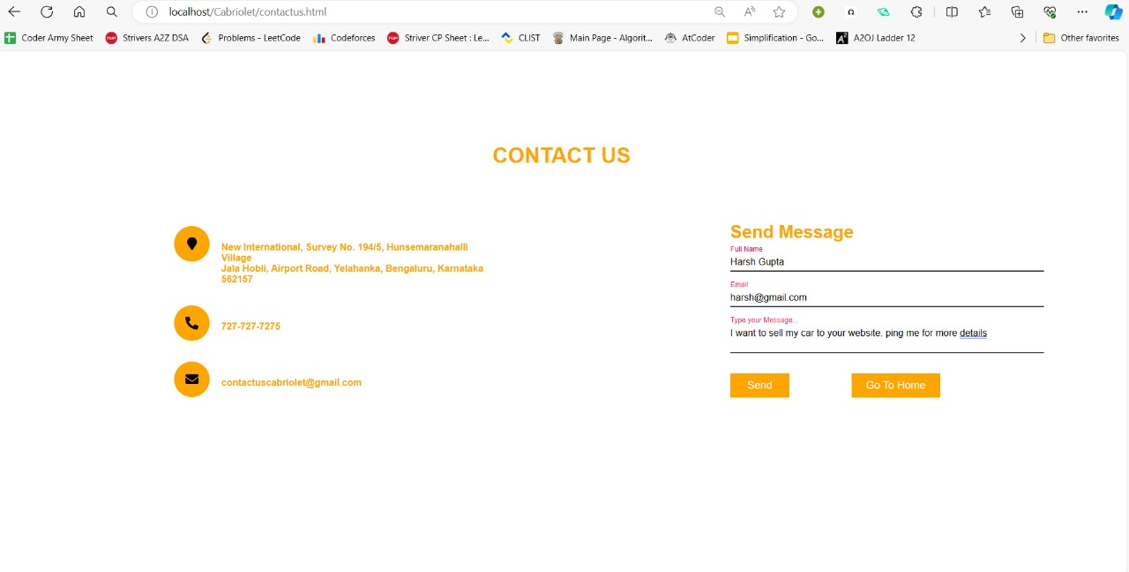

**Fig 7.2.10 Screenshot of Contact Us page**

Figure 7.2.10 indicates contact us page. It asks the user to enter details like full name, email, message where user can contact the company CaBrloLeT by sending message.

**7.2.11**

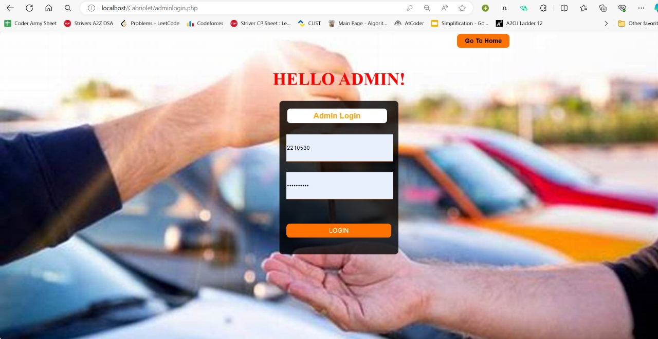

**Fig 7.2.11 Screenshot of Admin Login page**

Figure 7.2.11 indicates admin login page. It asks the admin to enter details like admin-id and password.

**7.2.12**

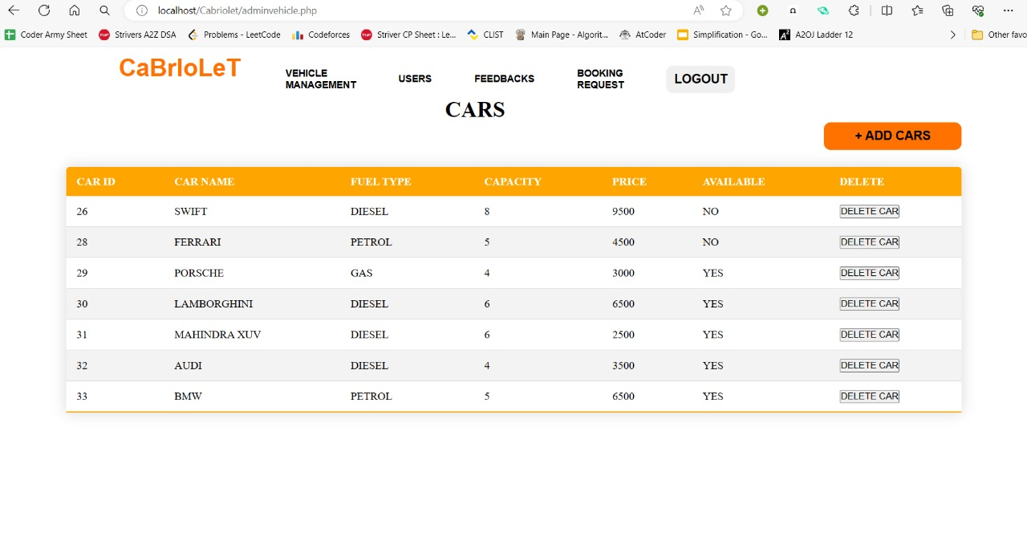

**Fig 7.2.12 Screenshot of Vehicle Management page**

Figure 7.2.12 indicates vehicle management page. It contains the details like car id, car name, fuel type, capacity, price, available, delete where admin can see the car availability status and delete the car details.

**7.2.13**

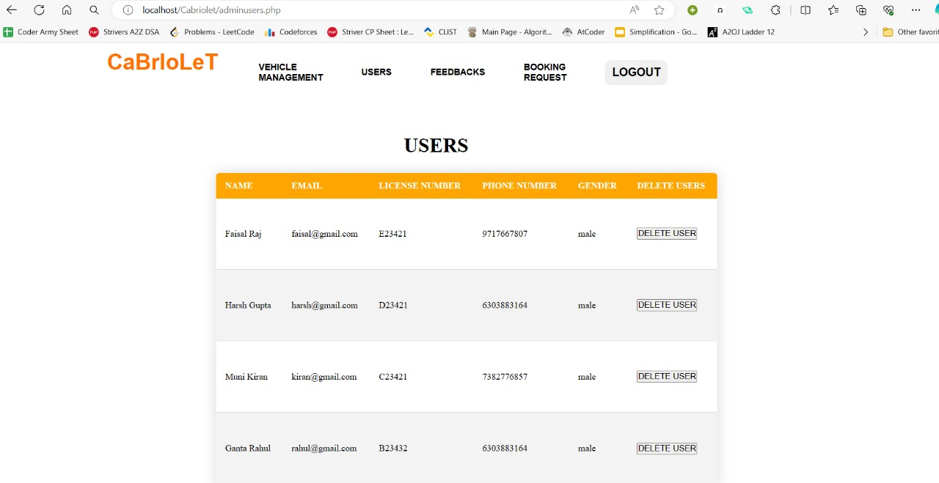

**Fig 7.2.13 Screenshot of Users page**

Figure 7.2.13 indicates User page. It includes details like name, email, license no, phone number, gender, delete user where admin can delete the user details.

**7.2.14**

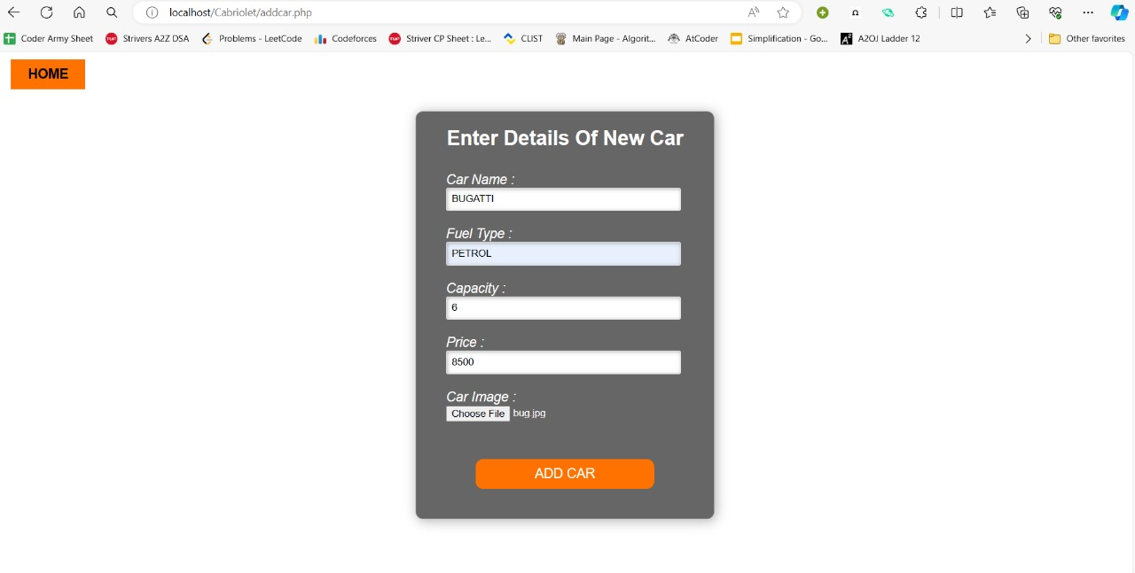

**Fig 7.2.14 Screenshot of Add Car page**

Figure 7.2.14 indicates add car page. It includes details like car name, fuel type, capacity, price, car image where admin can add the new car details by specifying it’s details.

**7.2.15**

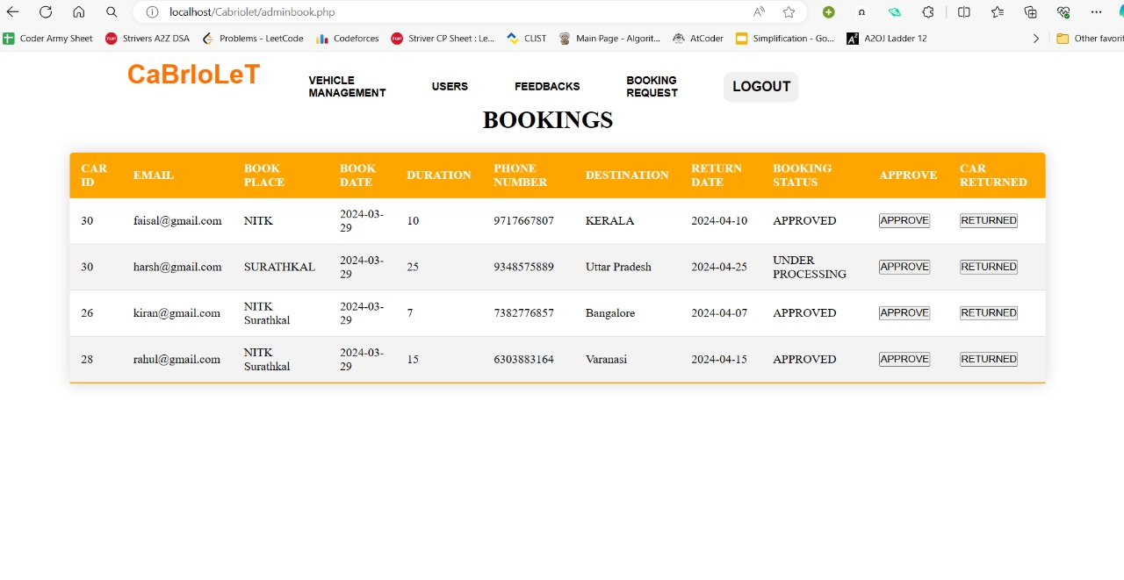

**Figure 7.2.15 Screenshot of Bookings page**

Figure 7.2.15 indicates booking page. It includes the details like car id, email, book place, book date, phone number, destination, return date, booking status, approve, car returned where admin can give approve to the bookings done by the user and can also check the returned status of the car.

8. **Conclusion**

**8.1 Summary of Project:**

The creation of a Car booking website using MySQL, PHP, HTML, and CSS aimed to automate and streamline car rental management processes. It resulted in the development of a robust Online Car Rental Management System. The system encompasses features such as car management, booking, feedback collection, and secure payment handling. Through diligent development and implementation, the project successfully achieved its objectives, providing a user-friendly interface for both administrators and customers.

**8.2 Achievements of Project Objectives:**

The project effectively manages the car fleet, facilitates seamless booking processes, collects and manages feedback, and handles payments securely. It incorporates comprehensive planning, clear communication, and collaboration among team members, ensuring smooth progress and timely delivery. Continuous testing and feedback loops were instrumental in identifying and resolving issues promptly. The system's flexibility allows for customization according to specific business needs, ensuring adaptability to changing requirements and future scalability. Overall, the project has not only met but exceeded expectations, providing a reliable and efficient solution for managing car rental operations.

**8.3 Lessons Learned:**

Several valuable lessons were learned throughout the project. Comprehensive planning and requirement analysis before development are crucial. Clear communication and collaboration among team members are essential for smooth progress and timely delivery. Continuous testing and feedback loops are vital in identifying and resolving issues promptly. The flexibility of the system architecture allows for customization according to specific business needs, ensuring adaptability to changing requirements and future scalability. Overall, the project underscores the importance of thorough planning, effective communication, and adaptability in successful project execution.

9. **References**

[1]Fundament also database system, Remez elmarsri Shamkanth b 7th edition,2017,

Pearson.

[2]The Joy of PHP Programming, Alan Forbes 5th edition, Plum Island.

[3]http://www.carrentingsolutions.com/

[4] https://youtu.be/BsDoLVMnmZs/

[5] https://www.w3schools.com/php

[6] https://www.tutorialspoint.com/javascript/index.htm/